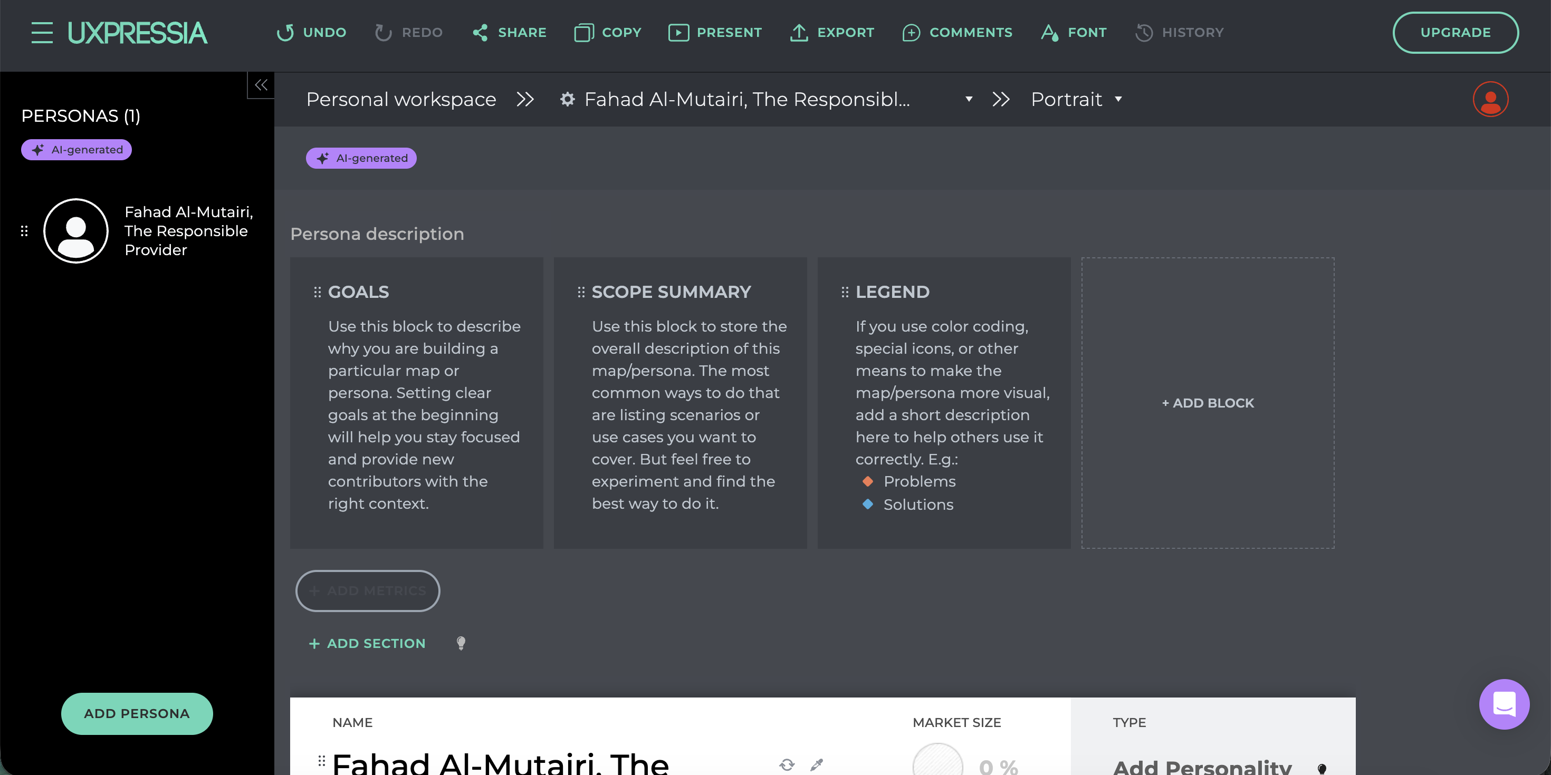

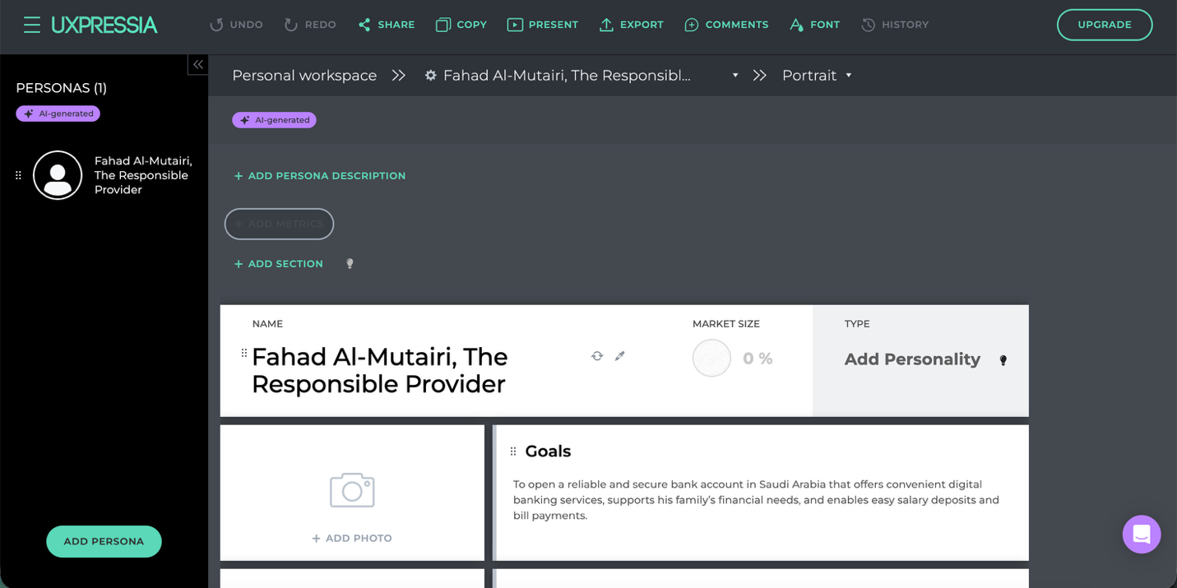

**1.1 Persona Name**

**Purpose:**  
Identifies the persona uniquely within a workspace/project.

**Field Type:**

* Text (editable inline)

**Behavior:**

* Editable on click
* Supports manual entry or AI-based name generation
* Updates instantly across navigation panels

**1.2 Persona Tag / Label**

**Example:**  
The Responsible Provider

**Purpose:**  
Summarizes the persona archetype or behavioral role.

**Field Type:**

* Short text / subtitle

**Usage:**

* Used for segmentation, filtering, and storytelling
* Displayed alongside persona name

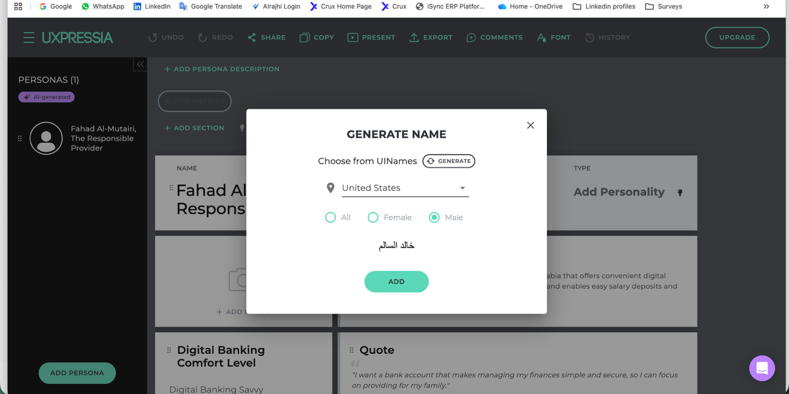

**Optional Controls:**

* Regenerate name (AI)
* Localization support (e.g., Arabic names)

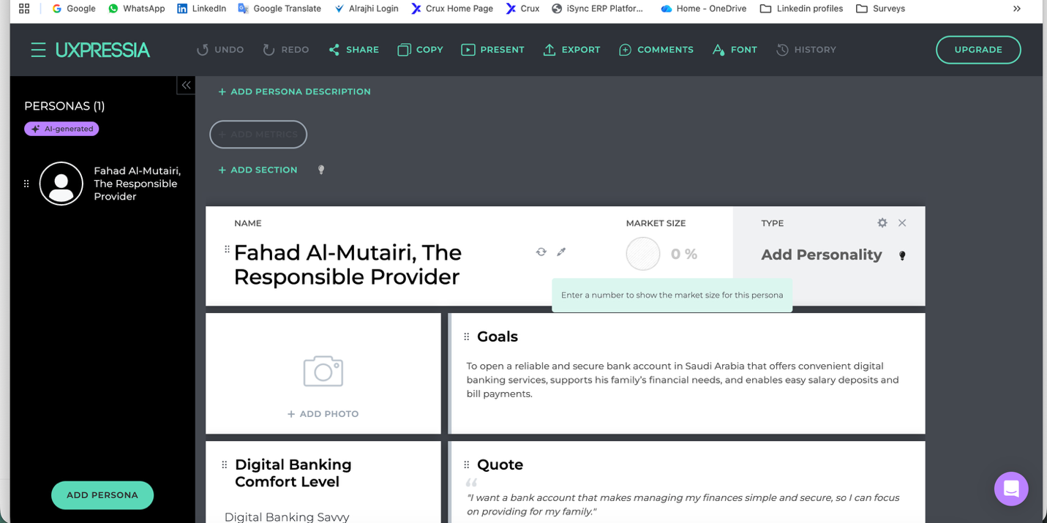

**1.3 Market Size (%)**

**Purpose:**  
Represents estimated proportion of users/customers that this persona represents.

**Field Type:**

* Numeric percentage (0–100%)

**Behavior:**

* Optional field
* Tooltip guidance (“Enter a number to show market size”)
* Visualized as a circular progress indicator

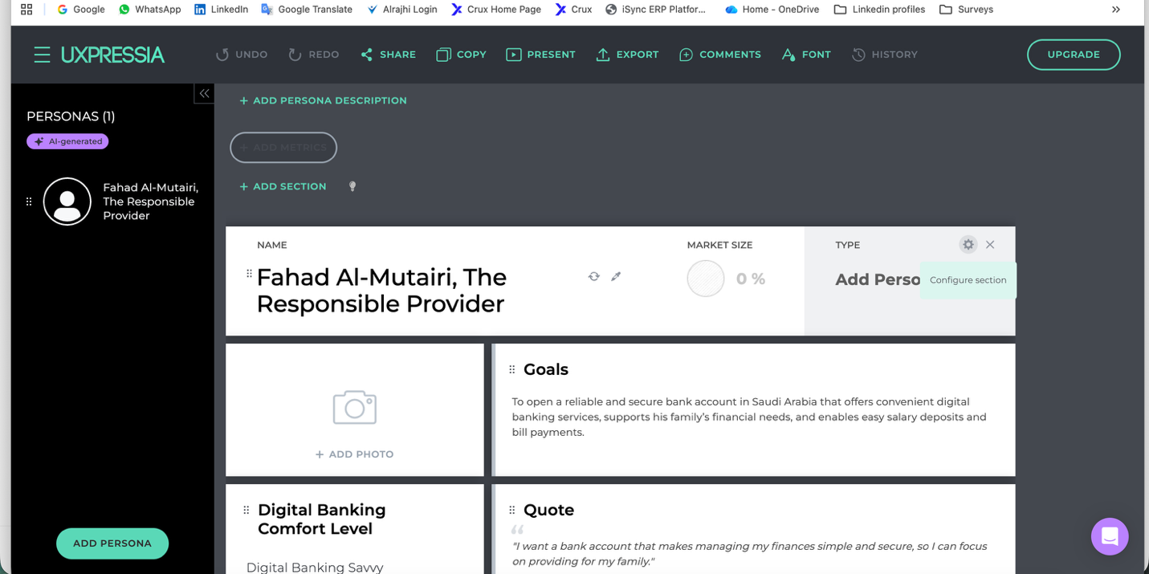

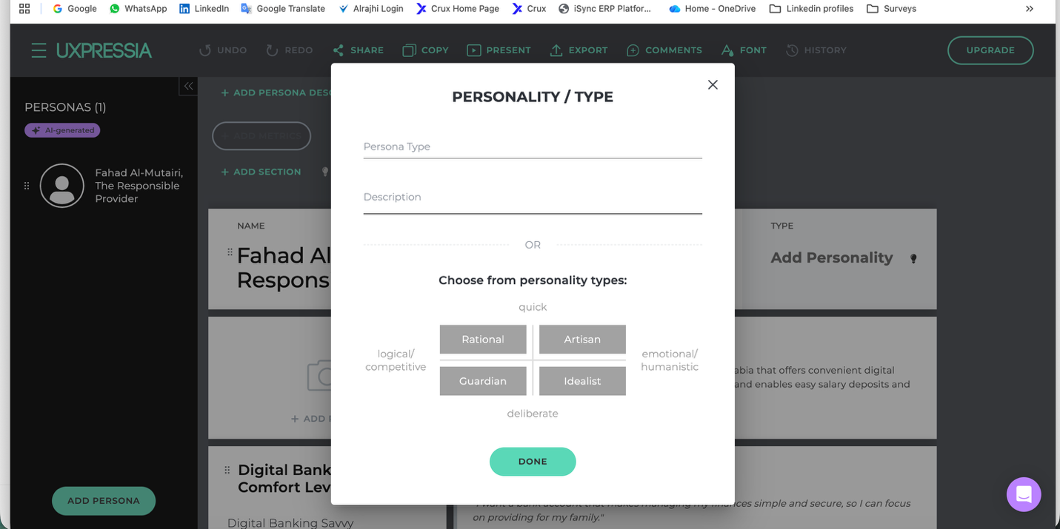

**1.4 Persona Type / Personality**

**Purpose:**  
Classifies persona based on behavioral decision style.

**Options (example taxonomy):**

* Rational
* Guardian
* Artisan
* Idealist

**Field Type:**

* Single-select predefined categories
* Optional custom text + description

**Usage:**

* Used by UX, product, and CX teams to infer decision-making patterns

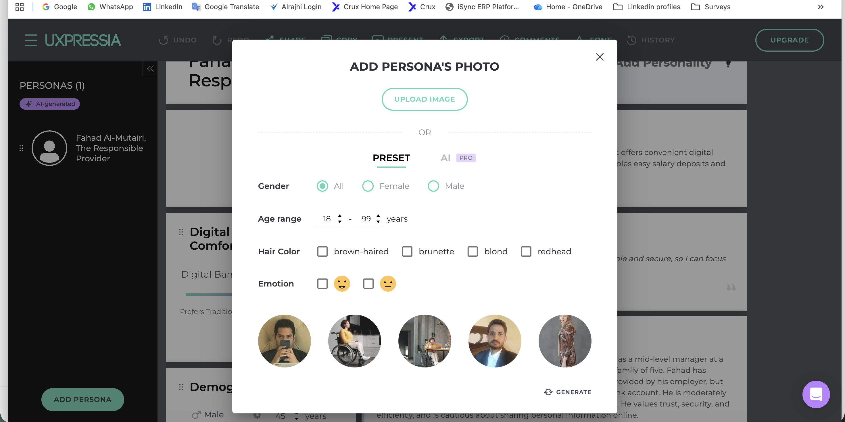

**2. Persona Visual Identity**

**2.1 Persona Photo**

**Purpose:**  
Humanizes the persona visually.

**Input Options:**

* Upload custom image
* Choose from preset stock avatars
* AI-generated avatar (optional)

**Controls:**

* Gender filter
* Age range
* Emotion (neutral / happy / serious)
* Regenerate avatar

**Validation:**

* Image size & format constraints
* Non-identifiable, representative imagery only

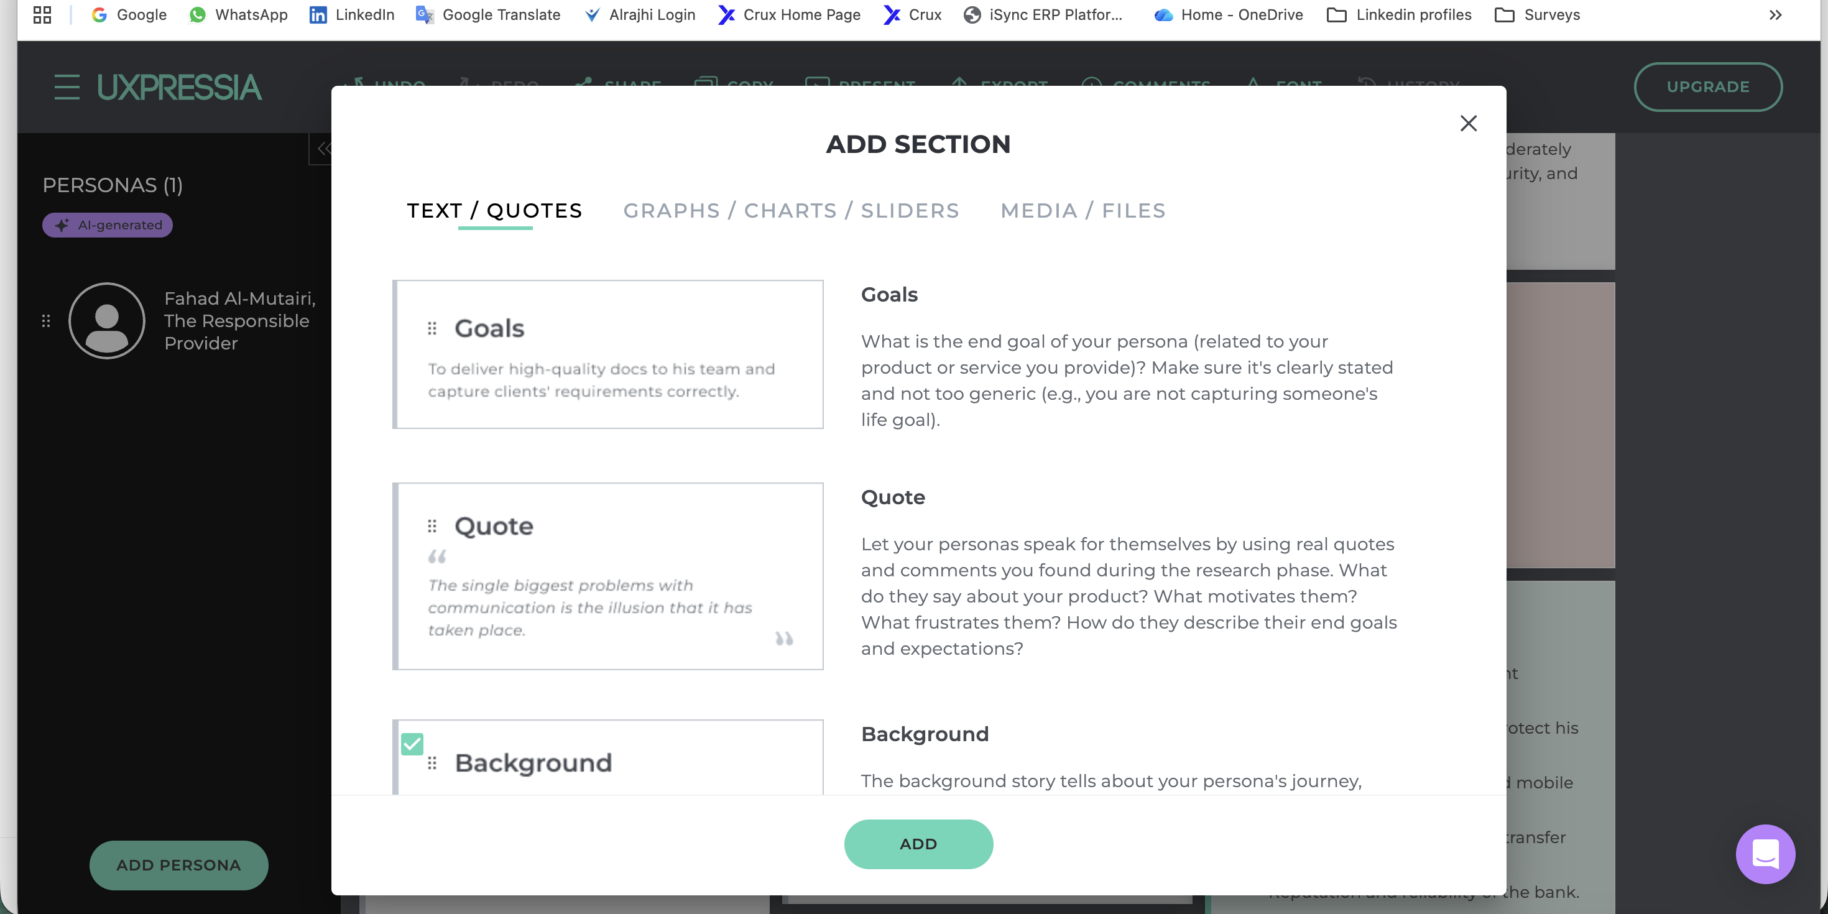

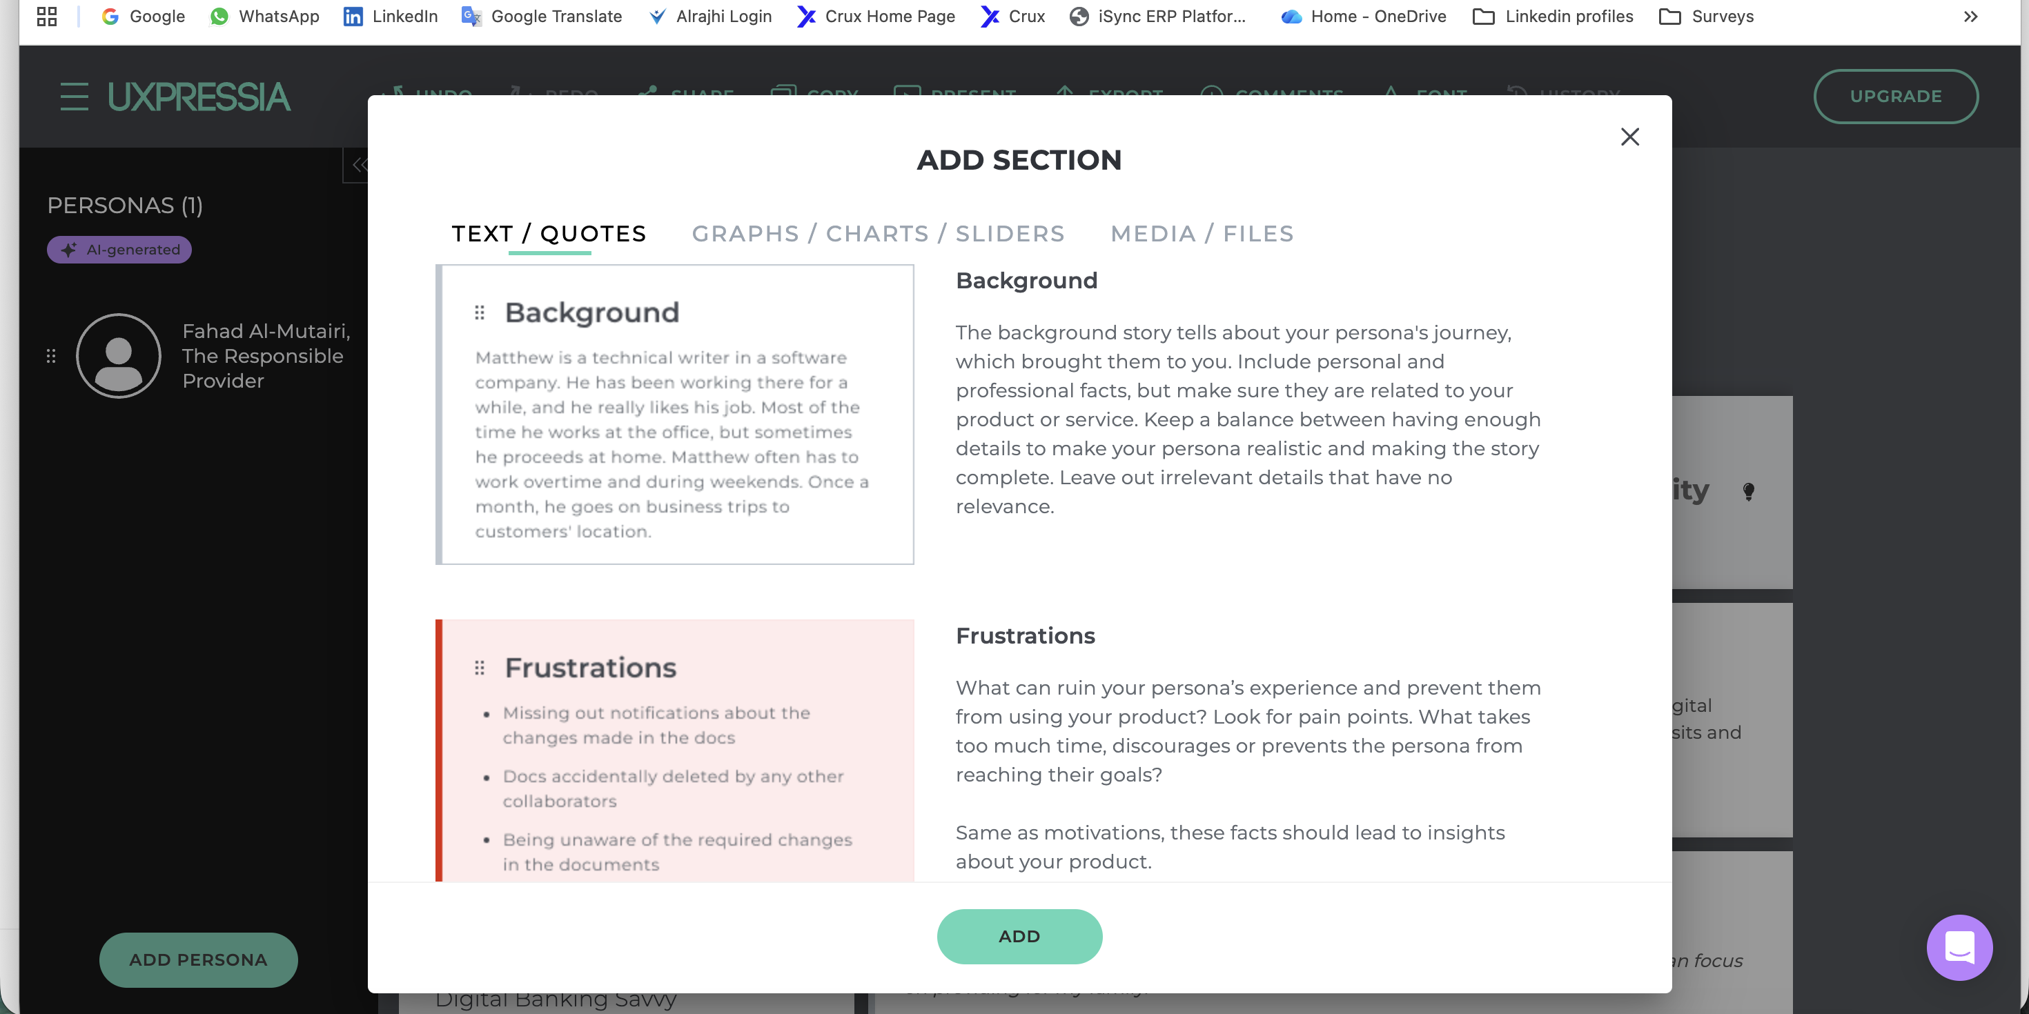

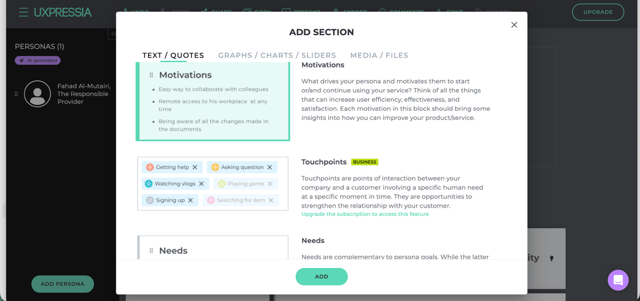

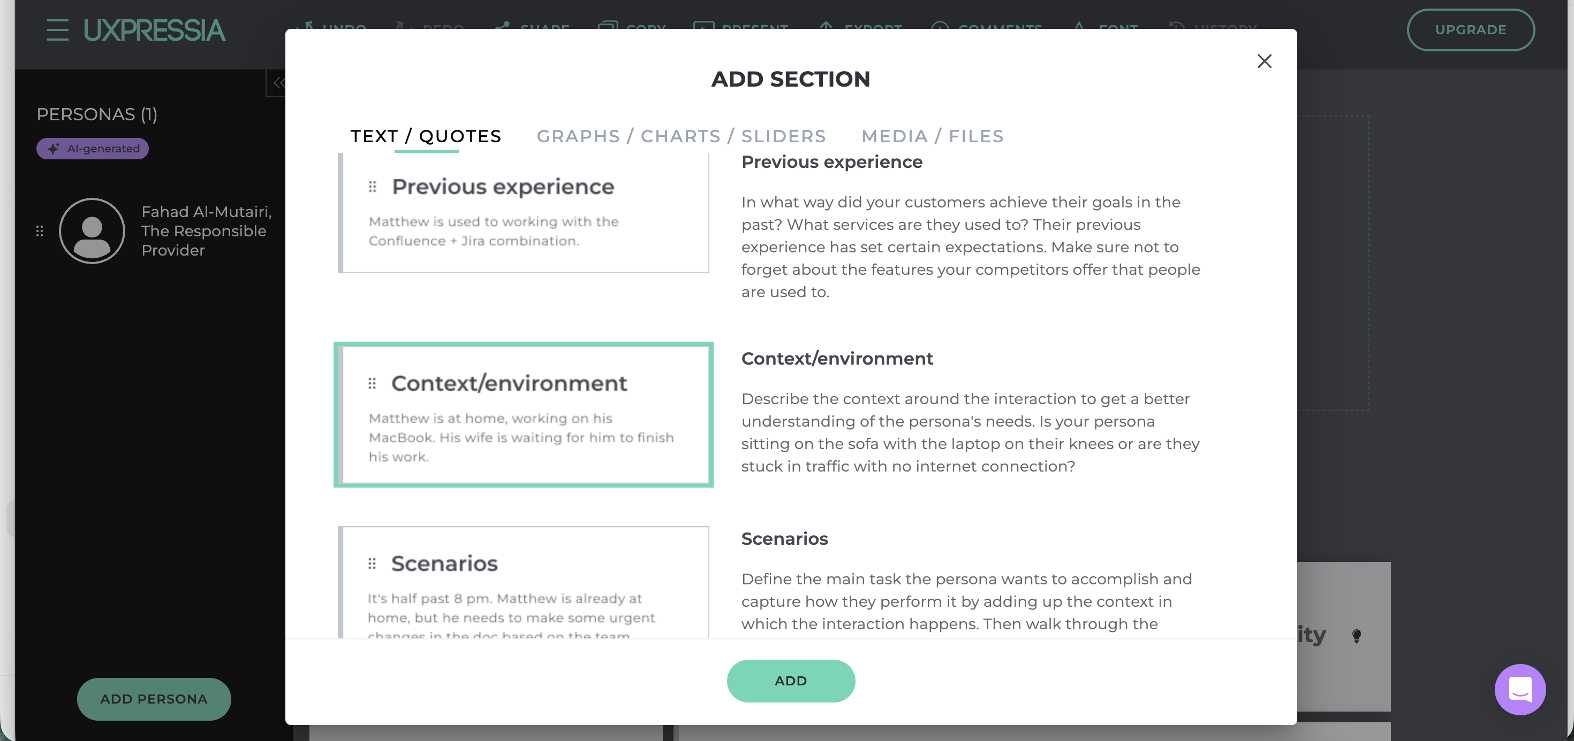

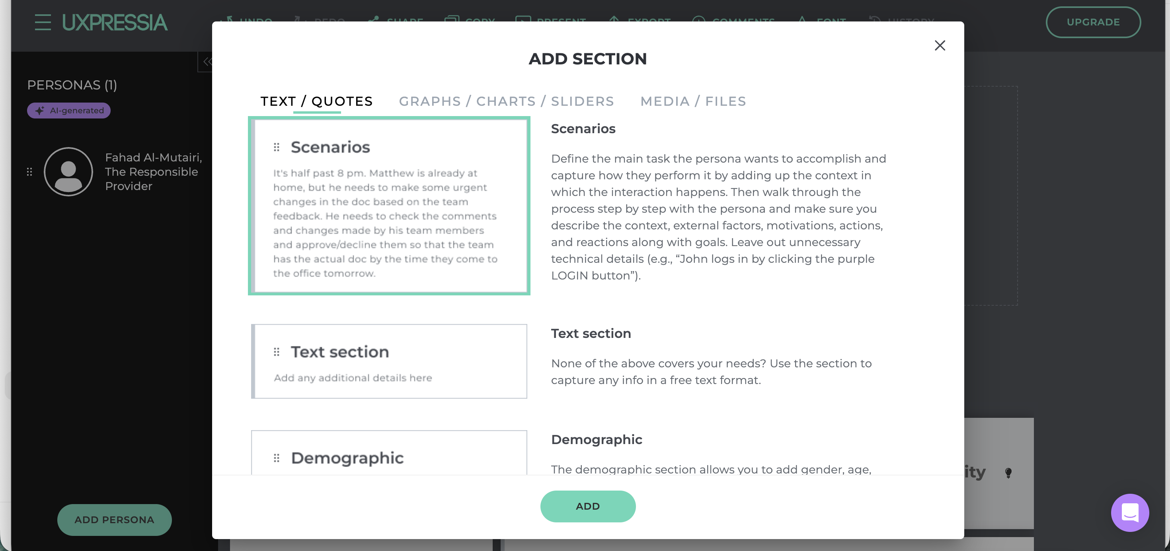

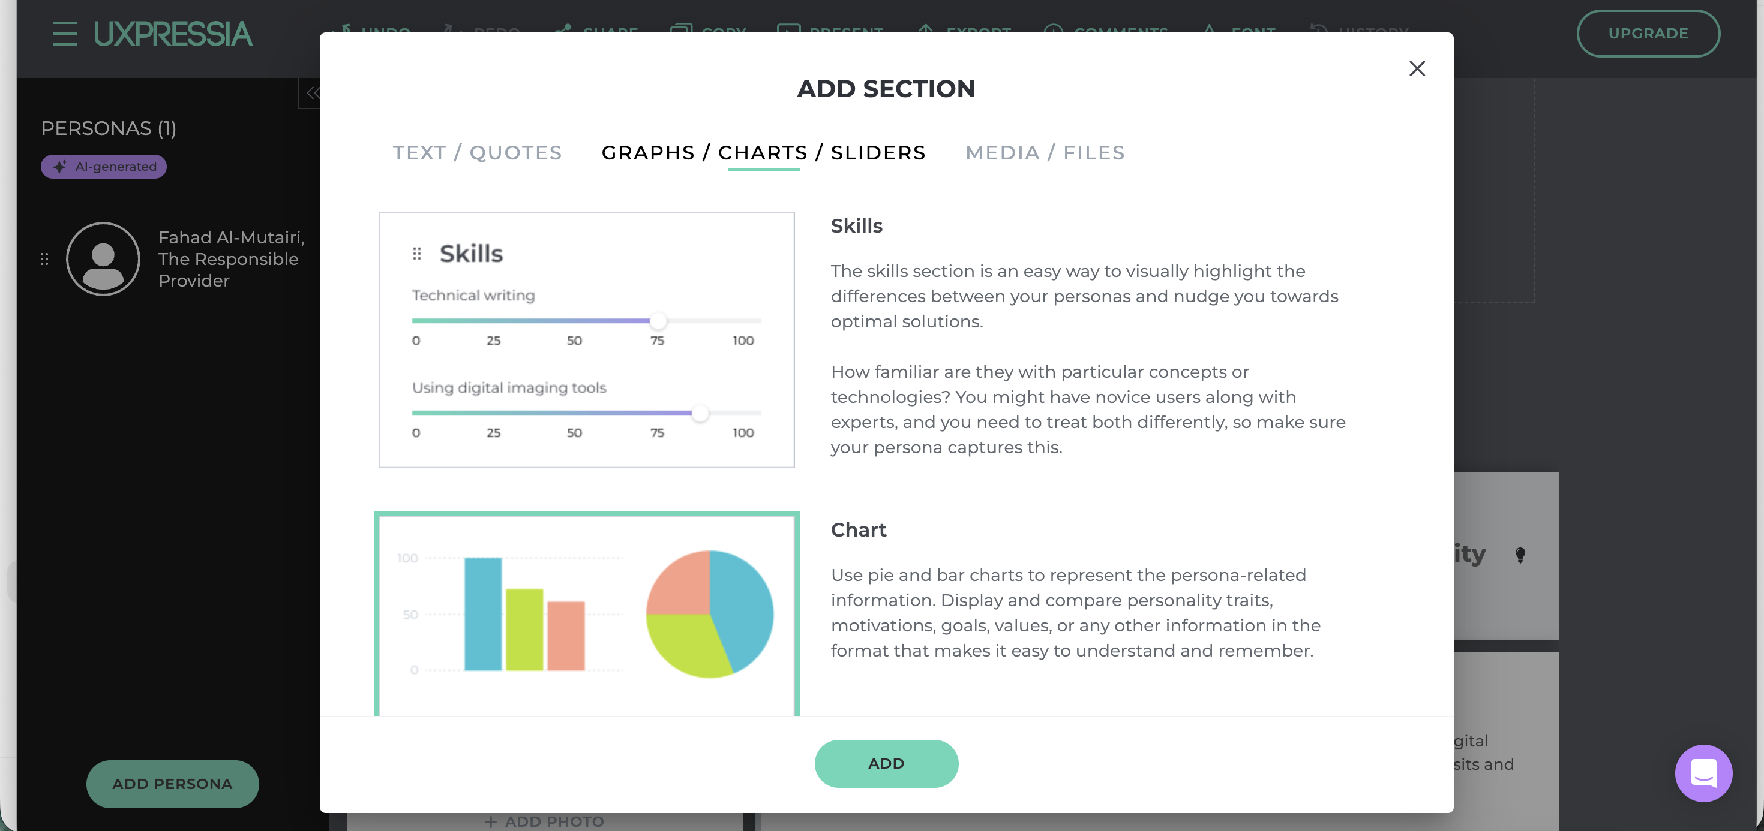

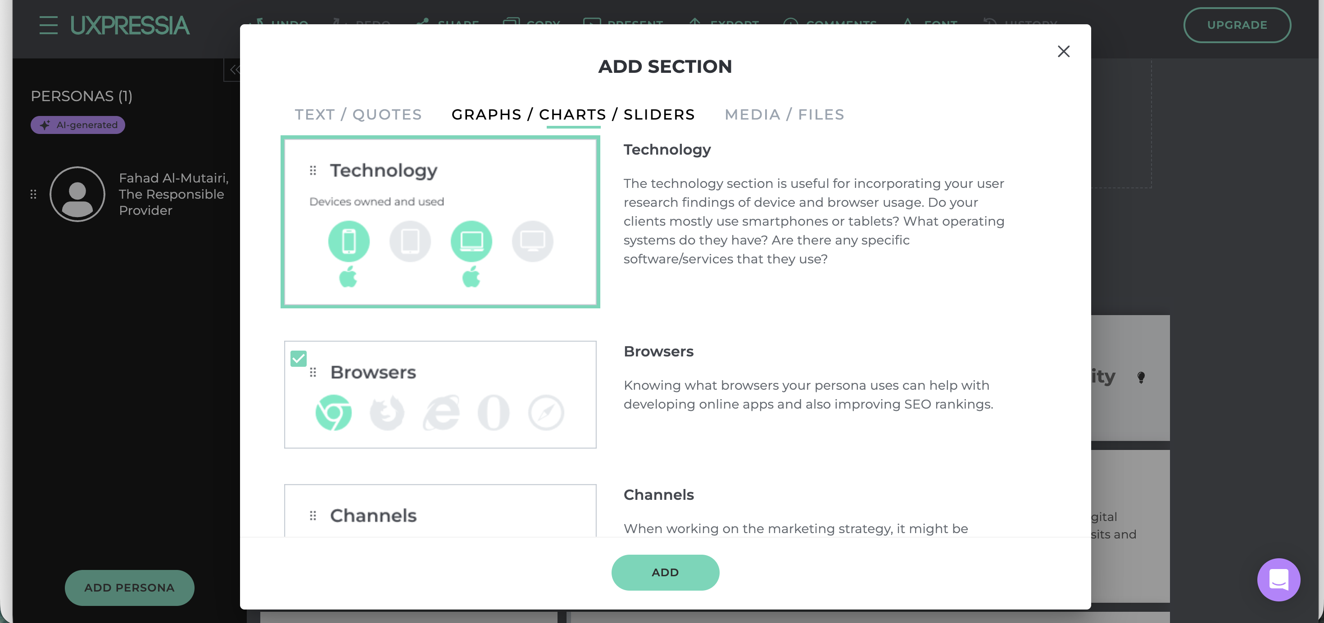

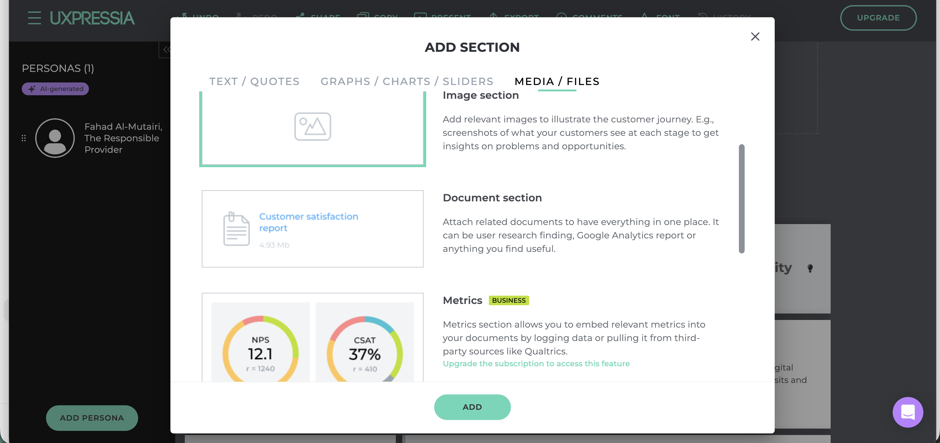

**3. Add Section**

**1. Purpose of the “Add Section” Feature**

The **Add Section** feature allows users to **extend a customer persona** by adding structured or unstructured information blocks.  
Each section represents a **specific dimension of customer understanding**, such as motivations, frustrations, context, skills, technology usage, or supporting media.

The system is designed to be:

* Modular
* Flexible
* Reusable across personas
* Non-restrictive (users choose only what’s relevant)

**2. Add Section Modal – General Behavior**

**Entry Point**

* User clicks **“+ Add Section”** within a persona canvas.

**Modal Layout**

* Modal overlay opens above the persona canvas.
* Title: **ADD SECTION**
* Close icon available (top-right).

**Section Categories (Tabs)**

1. **Text / Quotes**
2. **Graphs / Charts / Sliders**
3. **Media / Files**

Each tab displays a **list of available section templates** with:

* A preview card (visual sample)
* A short explanatory description

**Primary Action**

* **ADD** button  
  Adds the selected section to the persona canvas.

**3. TEXT / QUOTES Sections**

These sections capture **qualitative persona insights**.

**Background**

**What it captures**

* The persona’s life, work, and personal journey relevant to the product or service.

**How it’s used**

* Builds empathy
* Provides context for decision-making

**Content style**

* Narrative paragraph
* Focused only on relevant details

**Frustrations**

**What it captures**

* Pain points and irritations that negatively affect the persona’s experience.

**Format**

* Bullet points

**Usage**

* Identifies UX, service, or process gaps
* Direct input for improvement opportunities

**Motivations**

**What it captures**

* Factors that encourage adoption or continued usage.

**Format**

* Bullet points

**Usage**

* Helps teams understand what to emphasize in design, messaging, and features

**Needs**

**What it captures**

* Concrete requirements the persona needs to achieve goals.

**Difference from goals**

* Goals = high-level outcomes
* Needs = practical requirements

**Format**

* Bullet points or short text

**Expectations**

**What it captures**

* Baseline assumptions the persona has before using the product.

**Examples**

* Ease of integration
* Speed
* Reliability

**Format**

* Short paragraph

**Challenges**

**What it captures**

* Practical or situational obstacles faced by the persona.

**Difference from frustrations**

* Frustrations are emotional
* Challenges are operational or contextual

**Previous Experience**

**What it captures**

* Tools, platforms, or services the persona has already used.

**Purpose**

* Sets benchmarks and expectations
* Helps identify familiarity and learning curve

**Context / Environment**

**What it captures**

* The physical or situational environment in which interaction occurs.

**Examples**

* At home
* At work
* On the move
* Limited internet access

**Usage**

* Informs UX decisions and feature prioritization

**Scenarios**

**What it captures**

* A realistic, end-to-end story of how the persona interacts with the product.

**Focus**

* Actions
* Motivations
* External constraints
* Reactions

**Note**

* Avoids technical UI steps
* Focuses on human behavior

**Text Section (Generic)**

**What it captures**

* Any information not covered by predefined sections.

**Flexibility**

* User-defined title
* Free-form content

**Demographic**

**What it captures**

* Structured factual attributes.

**Typical fields**

* Gender
* Age
* Location
* Marital status
* Occupation
* Income band

**Notes**

* All fields are optional
* Custom fields allowed
* Should be research-driven, not assumed

**4. GRAPHS / CHARTS / SLIDERS**

These sections visualize **quantitative or comparative information**.

**Skills**

**What it captures**

* Proficiency levels across specific skills or competencies.

**Visualization**

* Sliders on a 0–100 scale

**Usage**

* Highlights differences between personas
* Guides complexity and onboarding decisions

**Charts**

**What it captures**

* Distribution or comparison of persona attributes.

**Supported visuals**

* Bar charts
* Pie charts

**Usage**

* Makes persona data easier to interpret and remember

**Technology**

**What it captures**

* Devices and platforms used by the persona.

**Visual style**

* Icon-based selection

**Examples**

* Smartphone
* Laptop
* Operating system preference

**Usage**

* Informs device-first or platform-first design decisions

**Browsers**

**What it captures**

* Browsers commonly used by the persona.

**Usage**

* Helps with web optimization and compatibility decisions

**Channels**

**What it captures**

* Preferred communication and interaction channels.

**Examples**

* Email
* WhatsApp
* Website
* Mobile app
* In-person

**Usage**

* Marketing and CX planning

**5. MEDIA / FILES**

These sections attach **supporting evidence and artifacts**.

**Image Section**

**What it captures**

* Visual references related to the persona or journey.

**Examples**

* Screenshots
* Journey snapshots
* Reference images

**Usage**

* Adds visual clarity
* Supports storytelling

**Document Section**

**What it captures**

* Research or reference documents.

**Examples**

* Survey reports
* Analytics files
* PDFs

**Purpose**

* Keeps persona insights and evidence in one place

**Metrics (Business Feature)**

**What it captures**

* Quantitative performance or experience metrics.

**Examples**

* NPS
* CSAT
* CES

**Usage**

* Links persona insights with real performance data

**6. Section-Level Behaviors (Global)**

Each section supports:

* Drag-and-drop reordering
* Inline editing
* Deletion
* Duplication
* Optional visibility based on subscription level

**7. Design Philosophy Behind the System**

* Personas are **not rigid templates**
* Users choose **only what is relevant**
* Sections encourage **thinking**, not form-filling
* Platform supports **UX, CX, product, and business teams equally**